CIS 4911 – Senior Project
Tractouch's iBLESS
User Manual

Team Members: Luis Miguel Carrillo
Mentor: Jaime Borras
04/26/2015
COPYRIGHTS AND TRADEMARK INFORMATION

This work is entirely done by Luis Miguel Carrillo unless written otherwise.

Create User

The user clicks on “Create User” on the navigation bar. Following this screen is displayed.


Click on add user in order to show the following pop up dialog.

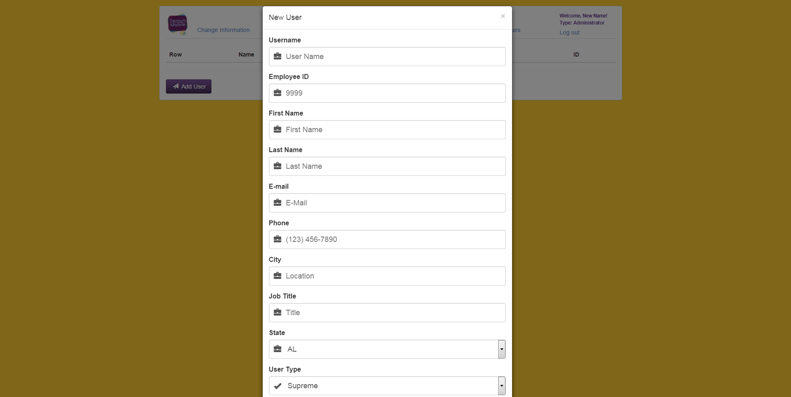
Completely fill the form (make sure the e-mail is correct given that it's with the new password), and click submit.

Delete User

Click on the blue label to display the actions available for this user. Click “Delete”.



Modify User info

Click on the blue label to display the actions available for this user. Click “Modify Info”.

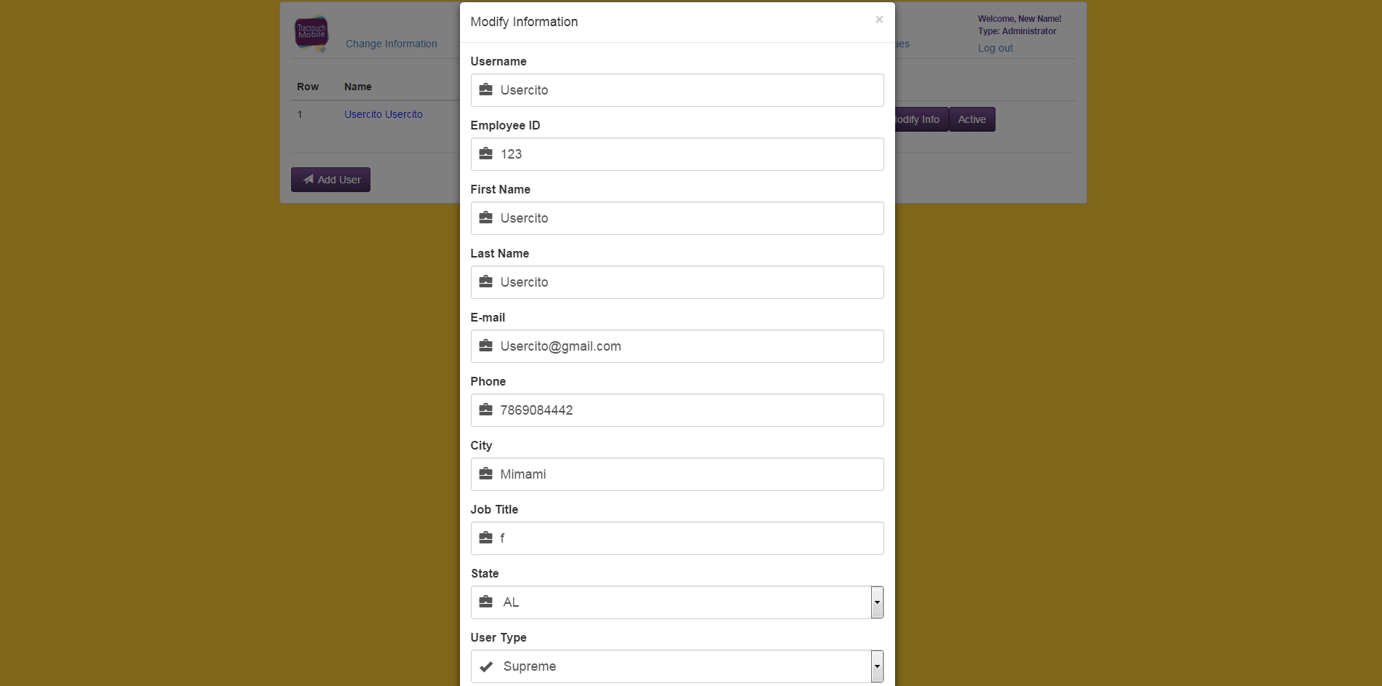
Modify all information that need to be changed and click submit.

Toggle Active Status

Click on the blue label to display all actions available for this user. Click on Inactive/Active (in this screen shot the user is inactive and therefore inactive is shown, had the user been active, active would have been shown).



